**PROJECT REPORT**

**1 INTRODUCTION**

1.1 OVERVIEW

Financial performance is a complete evaluation of a company’s overall standing in categories such as assets, liabilities, equity, expenses, revenue, and overall profitability. It is measured through various business-related formulas that allow users to calculate exact details regarding a company’s potential effectiveness.

1.2 PURPOSE

Its purpose is to convey an understanding of some financial aspects of a business firm. It may show a position of a period of time as in the case of a Balance Sheet, or may reveal a series of activities over a given period of time, as in the case of an Income Statement.

Financial analysis refers to the process of studying and assessing a company's financial statements—a collection of data and figures organized according to recognized accounting principles. The aim is to understand the company's business model, the profitability (or loss) of its operations, and how it's spending, investing, and generally using its money—summarizing the company by the numbers, so to speak

**2 PROBLEM DEFINITION AND DESIGN THINKING**

**2.1 Empathy Map:**

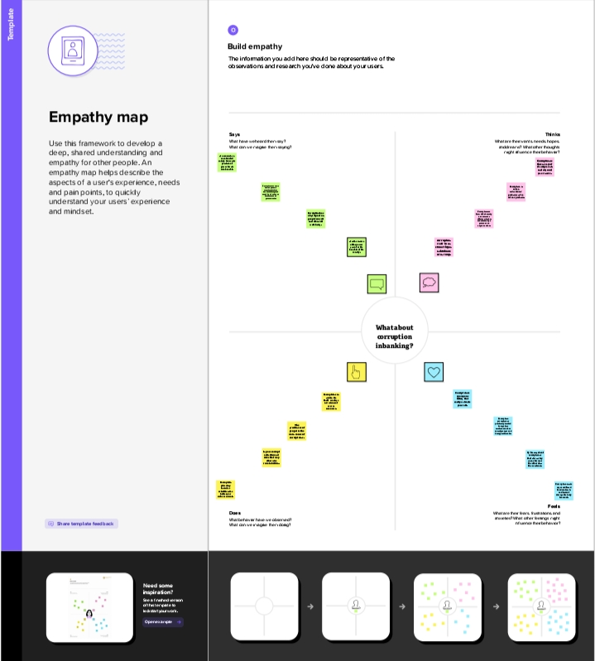

2.2 Idention and Brainstroming Map Result:

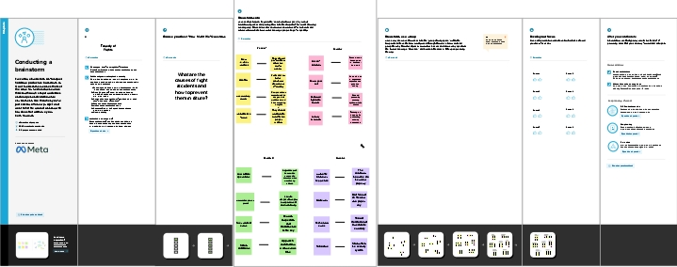

**3. RESULT**

DASHBOARD:

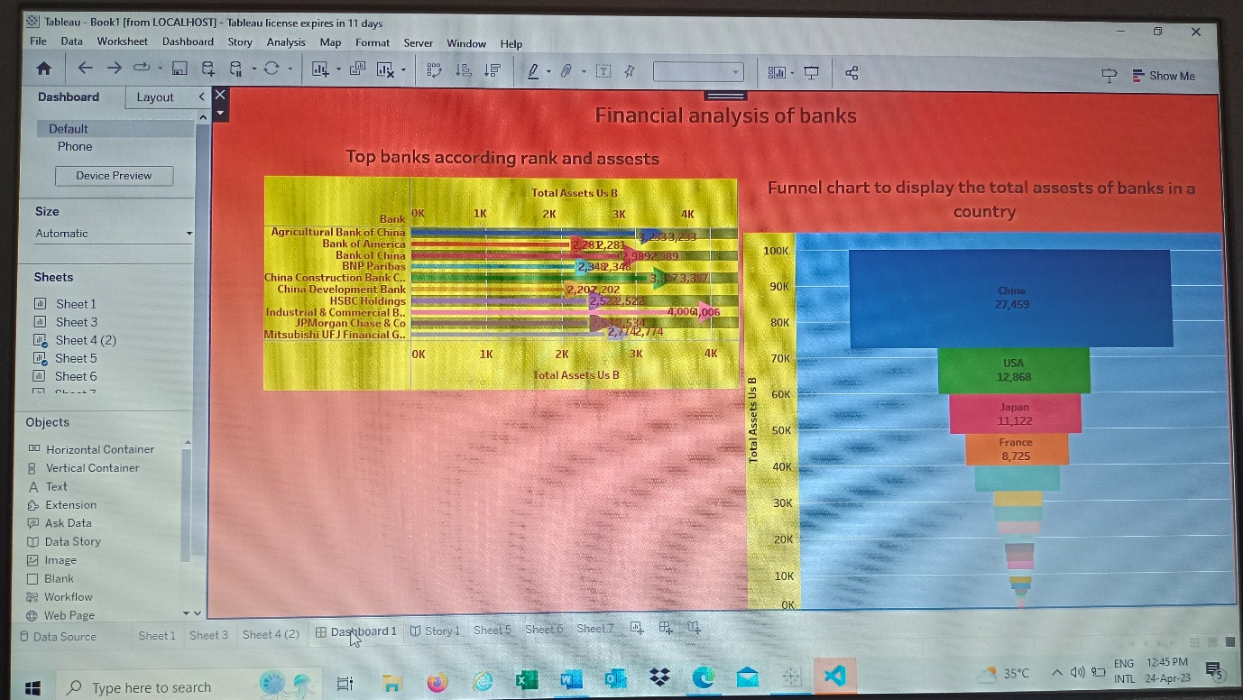

**STORY**

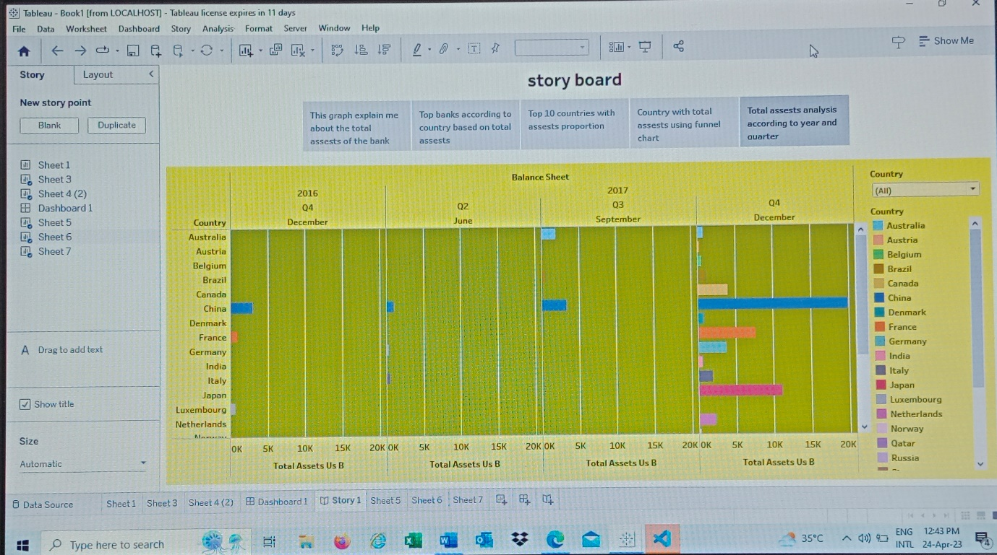

**4. ADVANTAGES AND DISADVANTAGES**

ADVANTAGES:

* **Evaluation Of Past Performance**

Financial statement analysis evaluates the past performance of business such as sales, cash flows, income, return on investment etc. by using different techniques like trend analysis, vertical analysis, ratio analysis etc.

* **Indication Of Current Position**

Financial statement analysis indicates the current financial position of the business in terms of profitability and operational efficiency.

* **Tax Determination**

Financial statement analysis shows accurate financial position and profitability of the business. So, it helps to determine tax liabilities of the company.

* **Credit Decision**

Financial statement analysis helps the bankers to make credit decision by providing up-to-date information regarding profitability, solvency, liquidity and efficiency of the business firm.

DISADVANTAGES:

* **Ignores Qualitative Aspect**

Financial statement analysis checks only quantitative or monetary aspect of the business. It totally ignores qualitative aspect.

* **Historical Data**

Financial statement analysis is done with the help of historical financial data provided by financial statements. So, it may not be a base or indicator for future estimation, planning, forecasting and decision making.

* **Biasness**

Financial statement analysis may suffer from the biasness of the analysts. This may mislead the users.

* **Does Not Provide Solution**

Financial statement analysis only identifies the finance related problems of the company. It fails to suggest the solutions.

**5. APPLICATIONS**

**# Evaluate a company’s past financial performance and explain how a company’s strategy is reflected in past financial performance :**  
  
Trends in a company’s financial ratios and differences between its financial ratios and those of its competitors or industry average ratios can reveal important aspects of its business strategy.

# **Forecast a company’s future net income and cash flow :**  
  
A company’s future income and cash flows can be projected by forecasting sales growth and using estimates of profit margins and the increases in working capital and fixed assets necessary to support the forecast sales growth.

**#   Role of financial statements analysis in assessing the credit quality of a potential debt investment :**  
  
Credit analysis uses a firm’s financial statements to assess its credit quality. Indicators of a firm’s creditworthiness include its scale and diversification, operational efficiency, margin stability, and use of financial leverage.  
  
**#   Use of financial statement analysis in screening for potential equity investments :**  
  
Potentially attractive equity investments can be identified by screening a universe of stocks, using minimum or maximum values of one or mire ratios. Which (and how many) ratios to use, what minimum or maximum values to use, and how much importance to give each ratio all present challenges to the analyst.

**#   Appropriate analyst adjustments to a company’s financial statements to facilitate comparison with another company :**  
  
When companies use different accounting methods or estimates relating to areas such as inventory accounting, depreciation, capitalization, and off-balance-sheet financing, analysts must adjust the financial statements for comparability.  
  
LIFO ending inventory can be adjusted to a FIFO basis by adding the LIFO reserve. LIFO cost of goods sold can be adjusted to a FIFO basis by subtracting the change in the LIFO reserve.

When calculating solvency ratios, analysts should estimate the present value of operating lease obligations and add it to the firm’s liabilities.

**6. CONCLUSION**

This chapter discusses the role of financial analysis in company operation. Some financial analysts calculate net assets by subtracting goodwill, adding back unrealised capital gains, with inventories possibly being valued at their replacement cost. Calculating net assets is an even trickier task with consolidated accounts owing to minority interests and goodwill. A company will be able to create value during a given period if the return on capital employed that it generates exceeds the cost of the capital that it has raised to finance capital employed. The components of working capital are easily determined. Capital expenditure increases in cash and asset disposals can also be established very rapidly, even in a sub-par accounting system. A reverse cash flow statement can be used to provide a very rough estimate of company's earnings, even before they have been reported.

**7. FUTURE SCOPE**

* Analyze financial ratios to assess profitability, solvency, working

capital management, liquidity, and operating effectiveness.

* Compare current performance with historical conditions using trend

analysis.

* Compare with peer companies or industry averages to find out how

well companies are performing.